JMeter Integration with BlazeMeter

1. JMeter script recording
   1. Install a BlazeMeter plugin on the Chrome browser

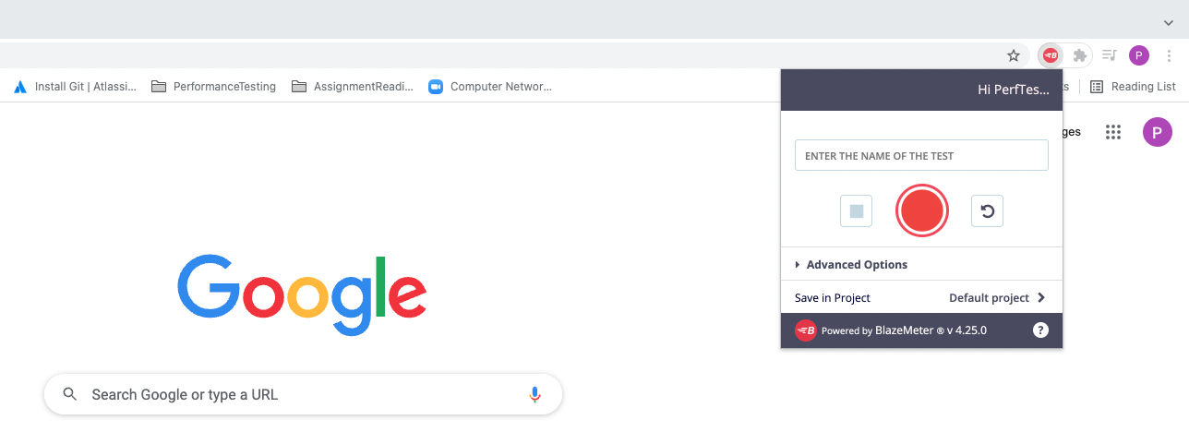

* 1. Enter details of the application URL and click record

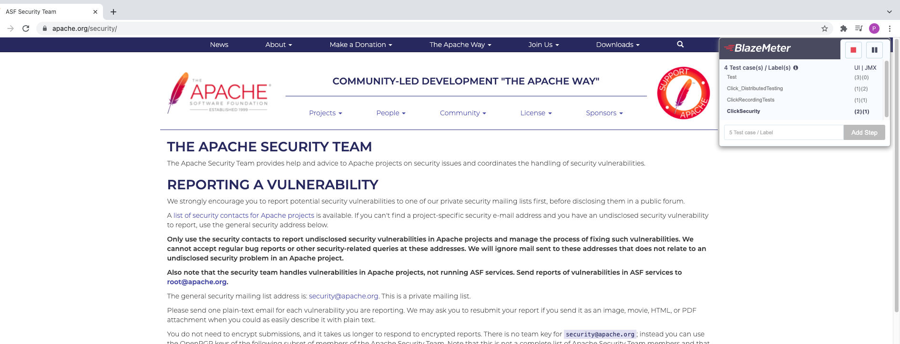

* 1. Enter Transaction names for each user request, and complete scenario
  2. Click on Stop recording

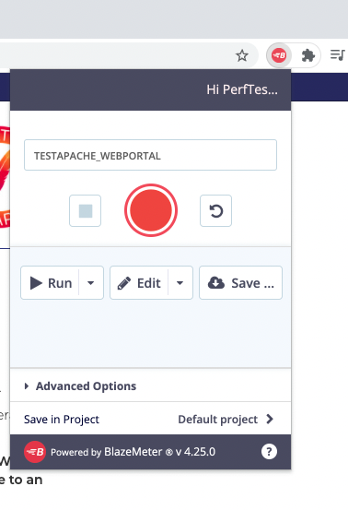

* 1. Click on Save JMeter file and then select format at .JMX

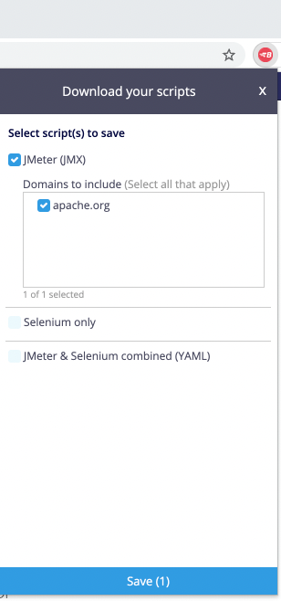

* 1. Open JMX file with JMeter – the script with transaction names will be generated on JMeter



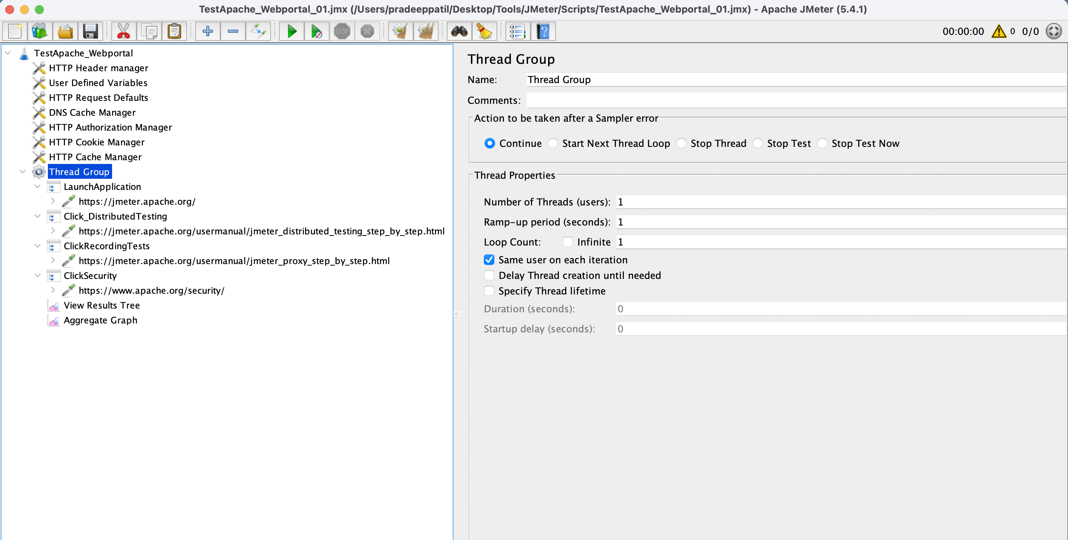

1. Load Test execution
   1. Login into the BlazeMeter Account

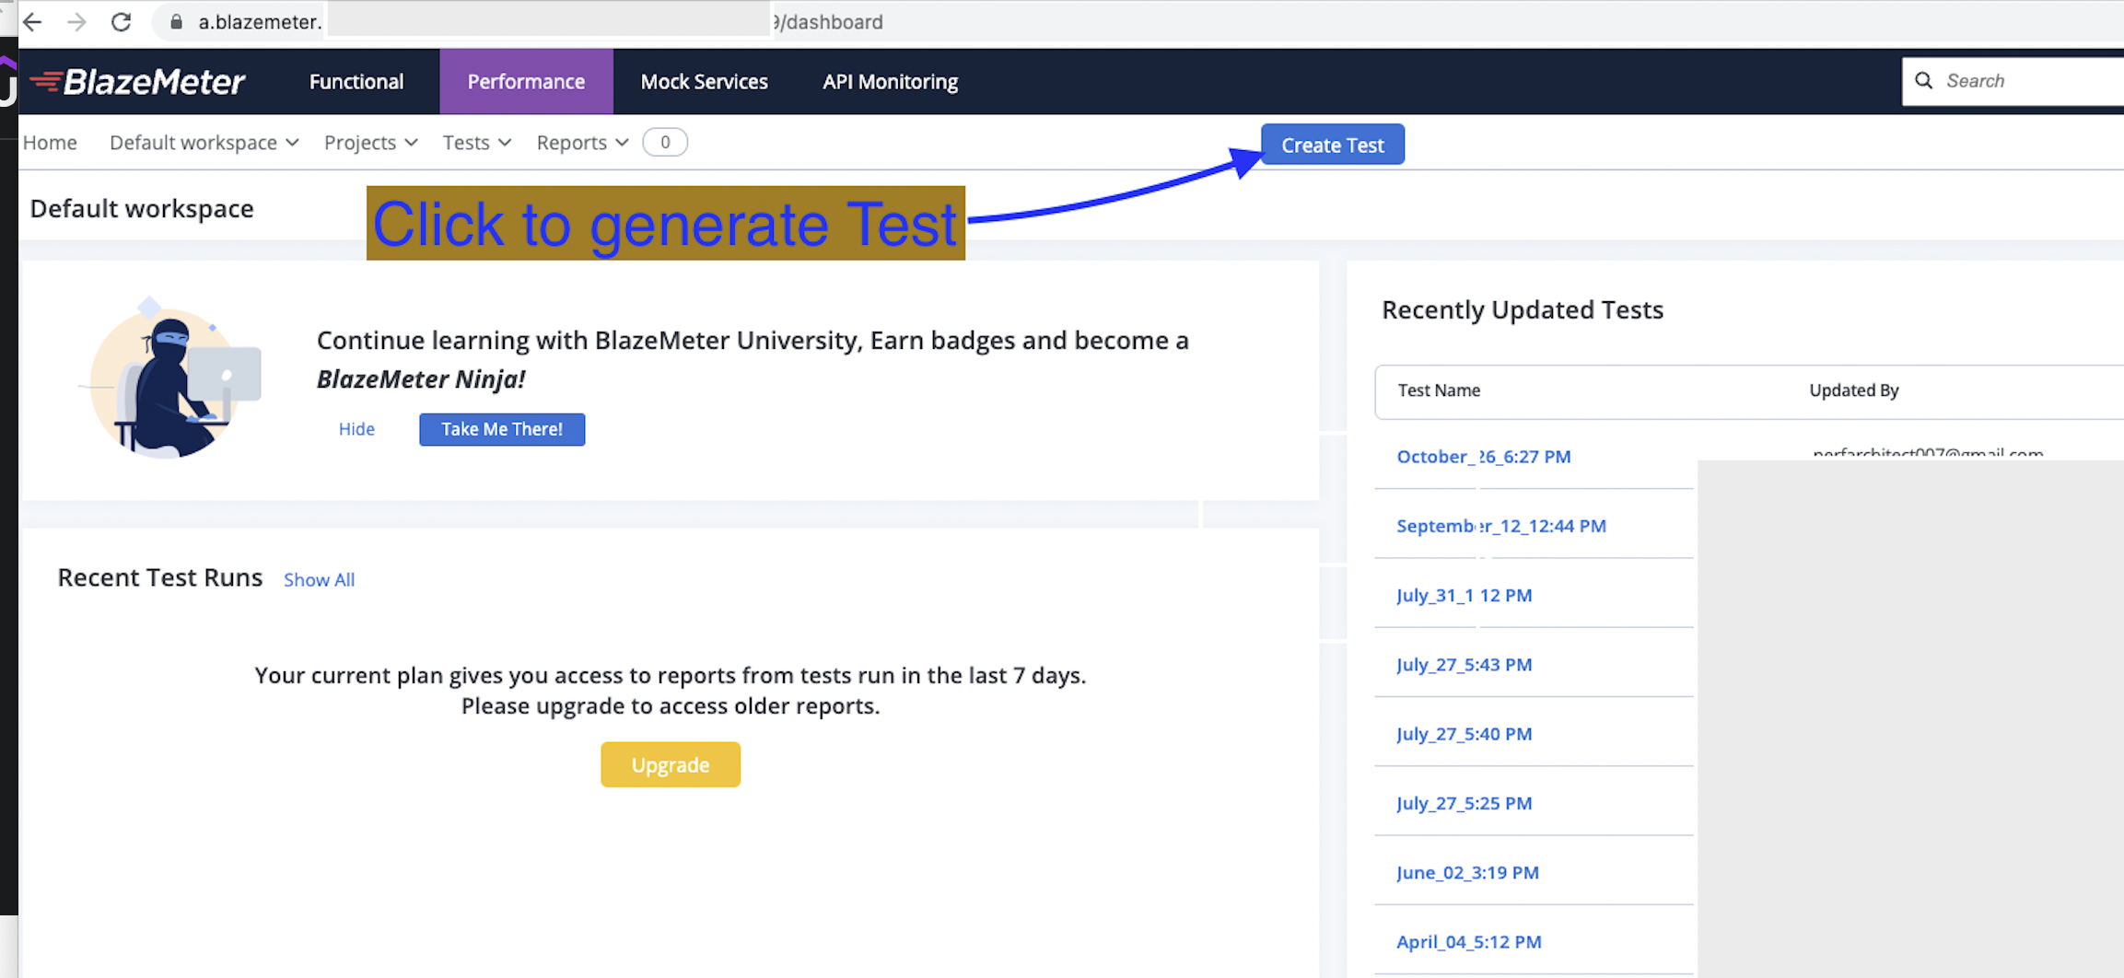

* 1. Click on create new project

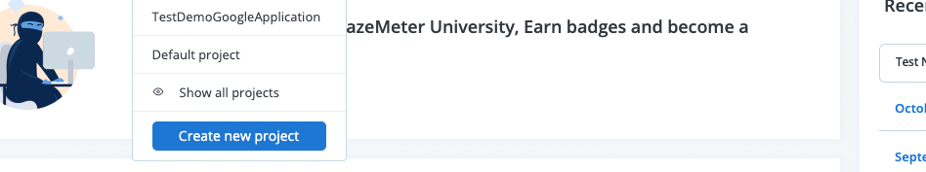

* 1. Edit scenario details on the performance icon
     1. Add number of virtual users
     2. Duration of test
     3. Ramp-Up time

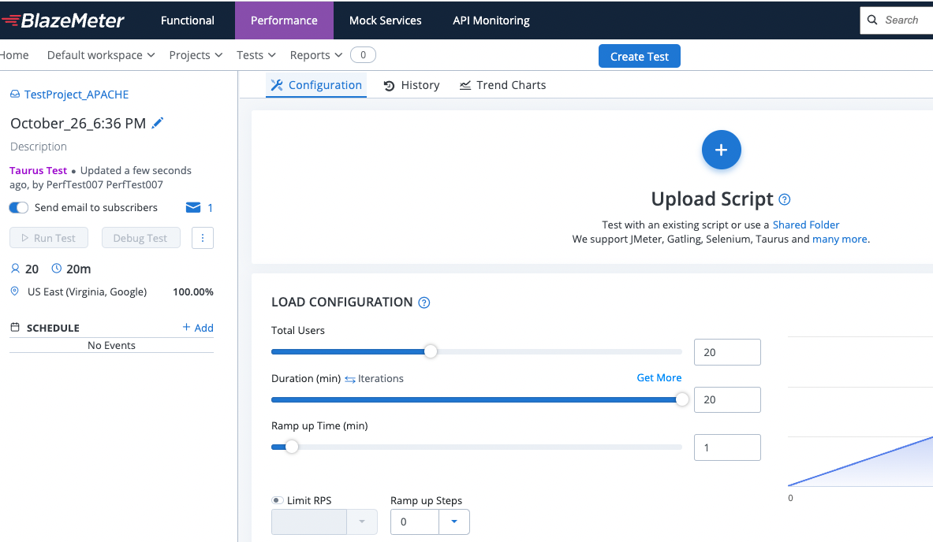

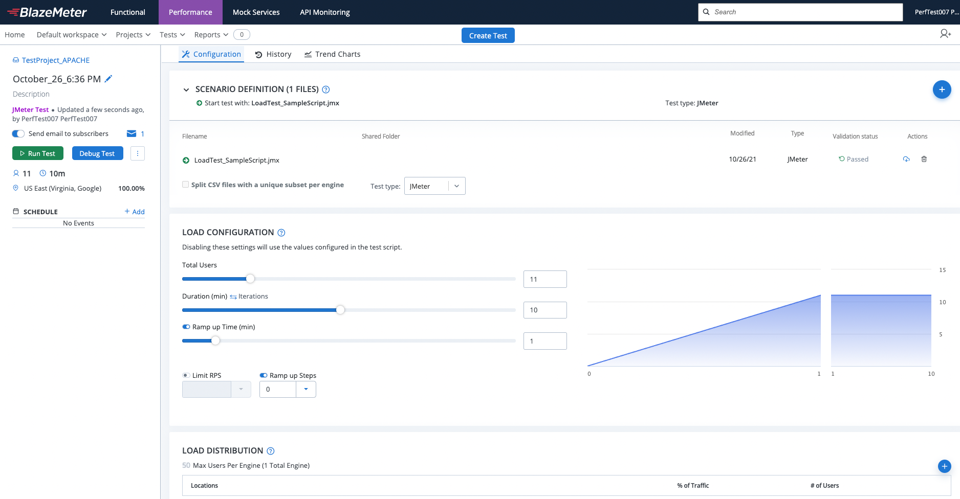

* 1. Click on the Run test

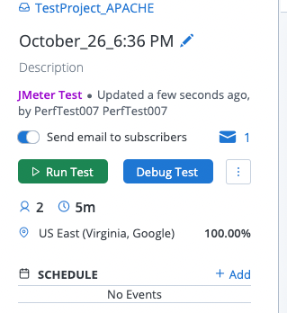

* 1. Verify details of the scenario execution and click on the Launch Server icon

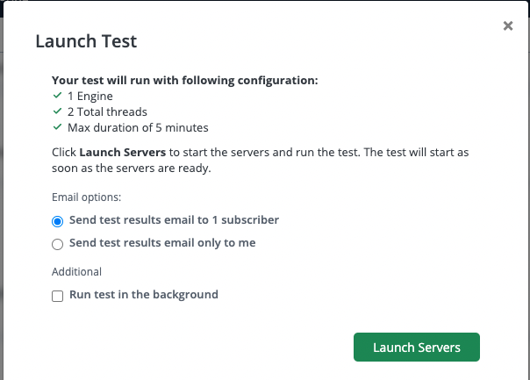

* 1. Warm up duration will send requests to test engine and validate the configuration is correct

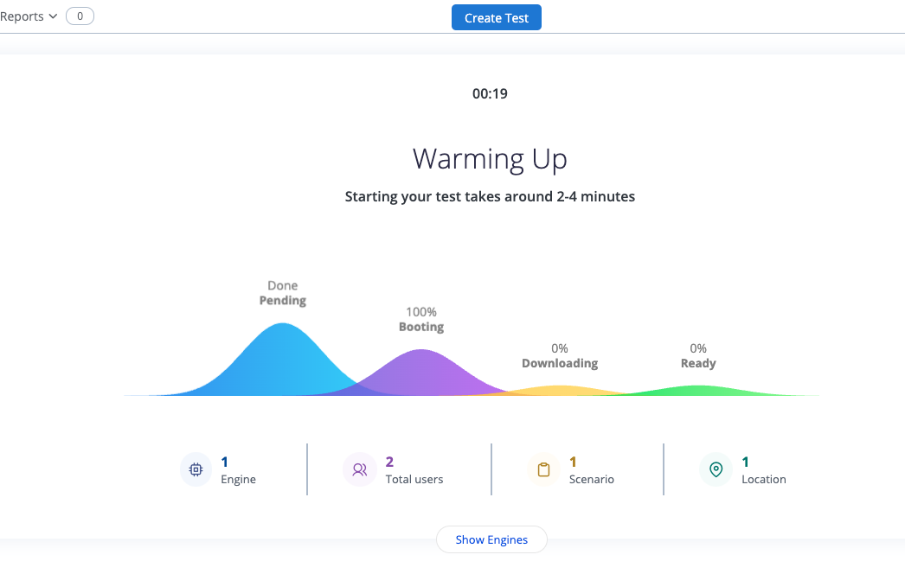

* 1. Finally, image shows when test will be ready for execution ( Ready % reaches to 100)

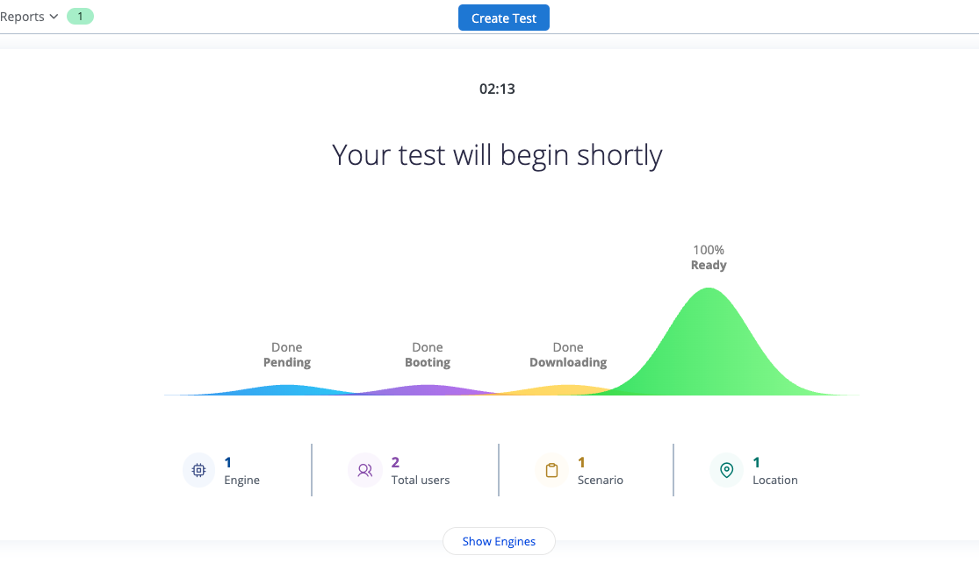

* 1. Monitor the test using online dashboard

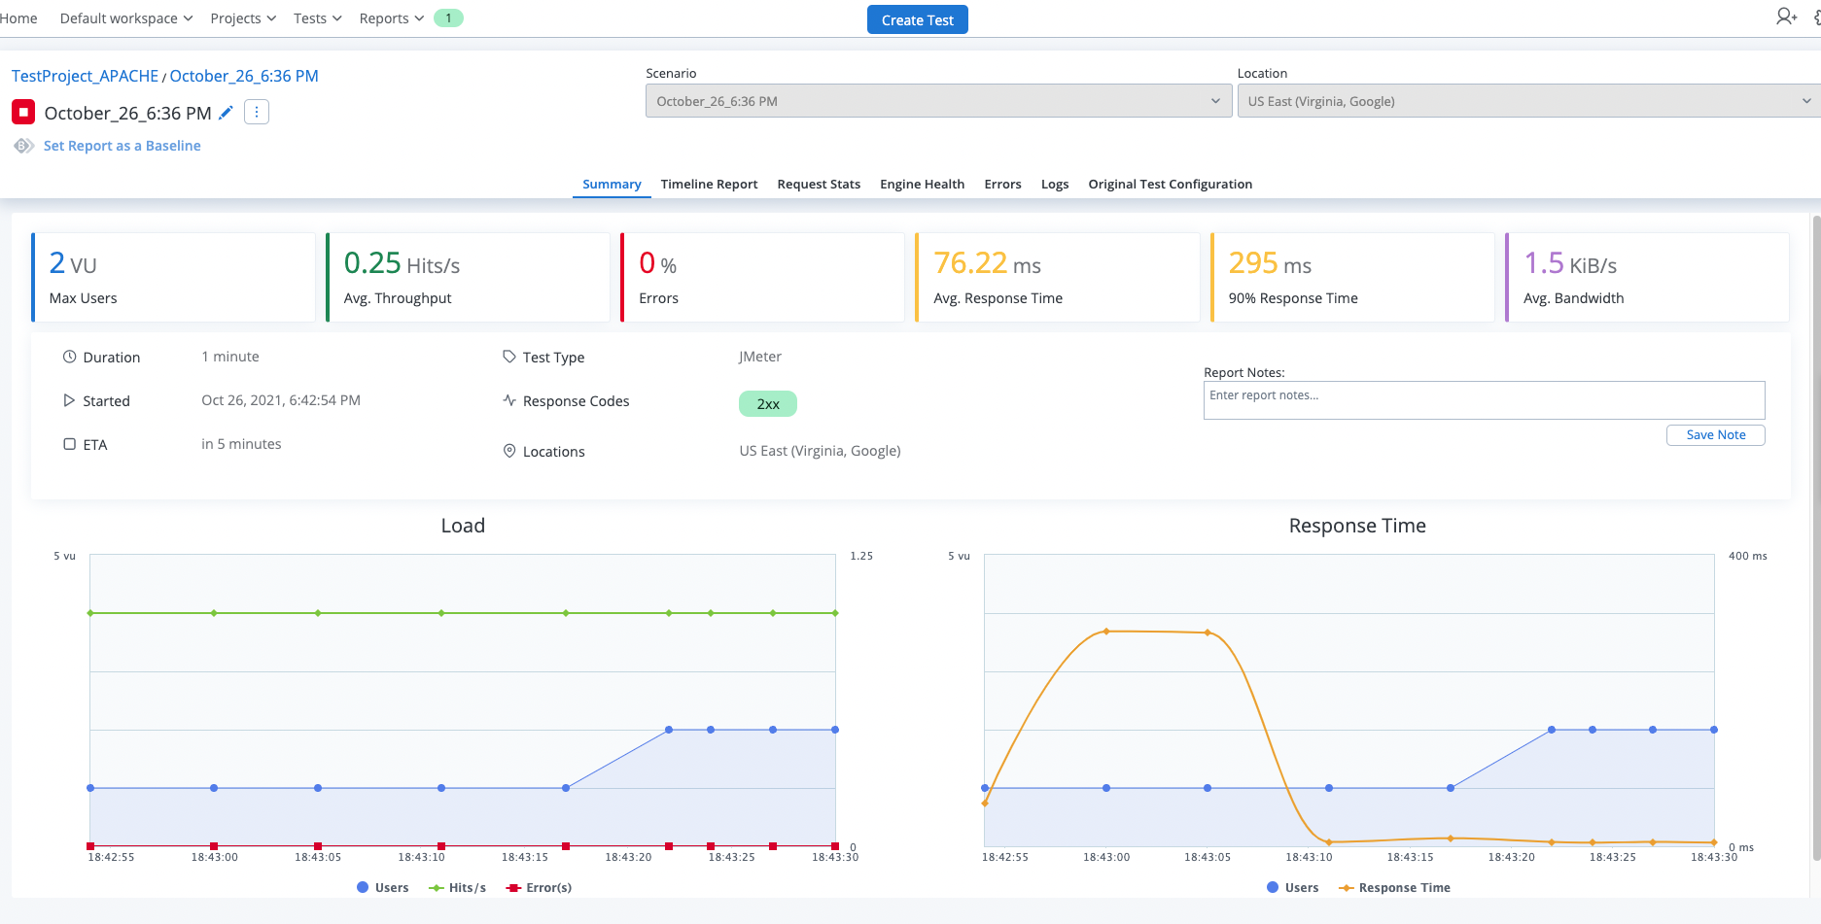

* 1. The dashboard gives statistics of the number of users running and response time details

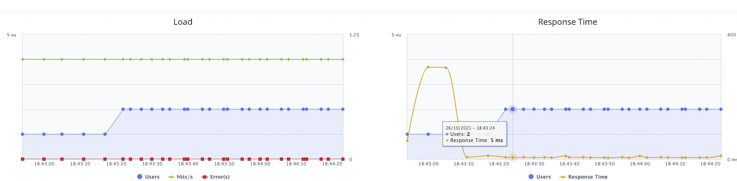

* 1. The summary table shows, transactions and respective response time details (avg,90%, pass, fail etc)

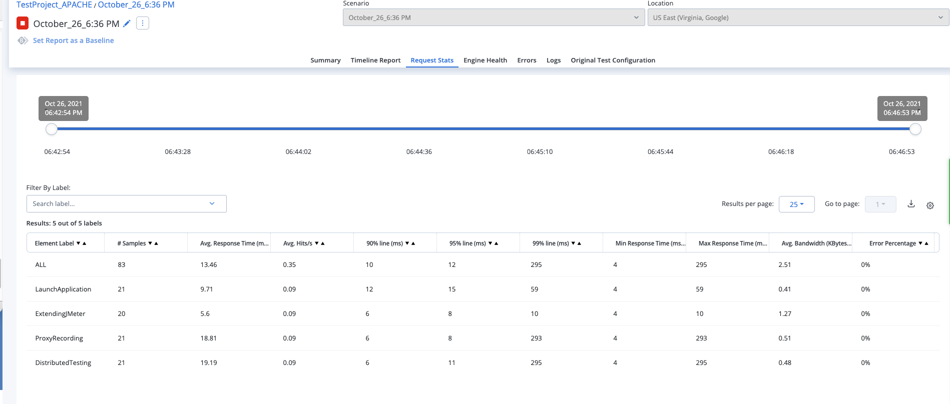

* 1. Post completion of the execution, a summary report will be ready to view

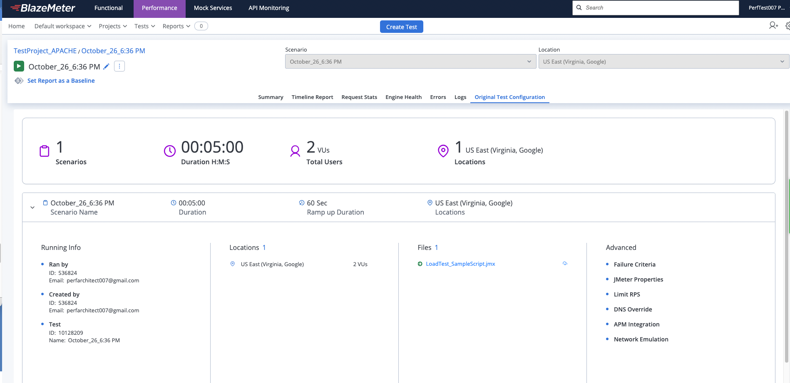

* 1. This report can be sent over to email for further distribution to project stakeholders

